AMRITA VISHWA VIDYAPEETHAM
AMRITA SCHOOL OF ENGINEERING
19CSE213-Lab 11
Solutions for classical problems of synchronization

Addition of 2 number using pthreads[No synchronization]
//sample addition without synchronization
#include <stdio.h>
#include <pthread.h>
#include <semaphore.h>
int a,b,sum;
sem_t s;
main() {
pthread_t f2_thread, f1_thread;
void *f2(), *f1();
pthread_create(&f1_thread,NULL,f1,NULL);
pthread_create(&f2_thread,NULL,f2,NULL);
pthread_join(f1_thread,NULL);
pthread_join(f2_thread,NULL);
}
void *f1(void){
printf("\nHELLO \n");
printf("Enter first number:");
scanf("%d",&a);
printf("Enter second number:");
scanf("%d",&b);
pthread_exit(0);
}

void *f2(void){
printf("Addition\n");
sum = a + b;
printf("Sum = %d\n",sum);
pthread_exit(0);
}

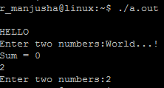
Addition of 2 numbers using pthread[semaphores]

//sample addition program to demonstrate use of semaphores
#include <stdio.h>
#include <pthread.h>
#include <semaphore.h>
int a,b,sum;
sem_t s;
main() {
sem_init(&s,0,0);
pthread_t f2_thread, f1_thread;
void *f2(), *f1();
pthread_create(&f1_thread,NULL,f1,NULL);
pthread_create(&f2_thread,NULL,f2,NULL);
pthread_join(f1_thread,NULL);
pthread_join(f2_thread,NULL);
}
void *f1(void){
printf("Enter the first number:");
scanf("%d",&a);
printf("Enter second number:");
scanf("%d",&b);
sem_post(&s);
pthread_exit(0);
}

void *f2(void){

sem_wait(&s);
sum = a + b;
printf("\nSum = %d",sum);
pthread_exit(0);
}

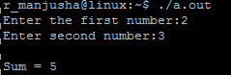
Dining Philosopher’s Problem –
Using pthreads(mutex lock)
#include <stdio.h>
#include <stdlib.h>
#include <pthread.h>

pthread_t philosopher[5];
pthread_mutex_t chopstick[5];

void *func(int n)
{
printf ("Philosopher %d is thinking\n",n);

//when philosopher 5 is eating he takes fork 1 and fork 5
pthread_mutex_lock(&chopstick[n]);
pthread_mutex_lock(&chopstick[(n+1)%5]);
printf ("Philosopher %d is eating\n",n);
sleep(3);
pthread_mutex_unlock(&chopstick[n]);
pthread_mutex_unlock(&chopstick[(n+1)%5]);

printf ("Philosopher %d finished eating\n",n);

return(NULL);
}

int main()
{
int i;
for(i=0;i<5;i++)
pthread_mutex_init(&chopstick[i],NULL);

for(i=0;i<5;i++)
pthread_create(&philosopher[i],NULL,(void *)func,(void *)i);

for(i=0;i<5;i++)
pthread_join(philosopher[i],NULL);

for(i=0;i<5;i++)
pthread_mutex_destroy(&chopstick[i]);

return 0;
}

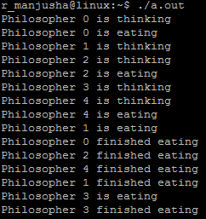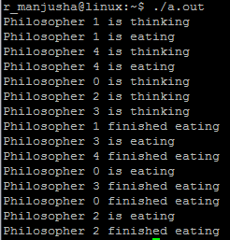

Dining Philosopher’s Problem –
Using pthreads(Semaphores)
#include<stdio.h>
#include<stdlib.h>
#include<pthread.h>
#include<semaphore.h>
#include<unistd.h>

sem_t room;
sem_t chopstick[5];

void * philosopher(void *);
void eat(int);
int main()
{
int i,a[5];
pthread_t tid[5];

sem_init(&room,0,4);
//initializing the semaphores
for(i=0;i<5;i++)
sem_init(&chopstick[i],0,1);

for(i=0;i<5;i++){
a[i]=i;
pthread_create(&tid[i],NULL,philosopher,(void *)&a[i]);
}
for(i=0;i<5;i++)
pthread_join(tid[i],NULL);
}

void * philosopher(void * num)
{
int phil=*(int *)num;

sem_wait(&room);
//Entered the room is used instead of the word thinking
printf("\nPhilosopher %d has entered room",phil);
sem_wait(&chopstick[phil]);
sem_wait(&chopstick[(phil+1)%5]);
//function eat is called(philosopher is eating – analogous to a process is
//running)
eat(phil);
sleep(2);
printf("\nPhilosopher %d has finished eating",phil);

sem_post(&chopstick[(phil+1)%5]);
sem_post(&chopstick[phil]);
sem_post(&room);
}

void eat(int phil)
{
printf("\nPhilosopher %d is eating",phil);
}

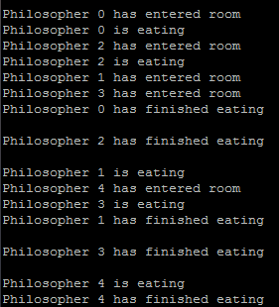
Consumer-Producer Problem –
Using pthreads(Mutex locks)
# include <stdio.h>
# include <pthread.h>
# define BufferSize 10

void *Producer();
void *Consumer();

int BufferIndex=-1;
char *BUFFER;

pthread_cond_t Buffer_Not_Full=PTHREAD_COND_INITIALIZER;
pthread_cond_t Buffer_Not_Empty=PTHREAD_COND_INITIALIZER;
pthread_mutex_t mVar=PTHREAD_MUTEX_INITIALIZER;

int main()
{
pthread_t ptid,ctid;

BUFFER = (char*) malloc(sizeof(char) * BufferSize);

pthread_create(&ptid,NULL,Producer,NULL);
pthread_create(&ctid,NULL,Consumer,NULL);

pthread_join(ptid,NULL);
pthread_join(ctid,NULL);

return 0;
}

void *Producer()
{ int i;
for(i=0;i<15;i++)
{
pthread_mutex_lock(&mVar);
if(BufferIndex==BufferSize)
{
pthread_cond_wait(&Buffer_Not_Full,&mVar);
}
BUFFER[BufferIndex++]='@';
printf("Produce : %d \n",BufferIndex);
pthread_mutex_unlock(&mVar);
pthread_cond_signal(&Buffer_Not_Empty);
}

}

void *Consumer()
{
int i;
for(i=0;i<15;i++)
{
pthread_mutex_lock(&mVar);
if(BufferIndex==-1)
{
pthread_cond_wait(&Buffer_Not_Empty,&mVar);
}
printf("Consume : %d \n",BufferIndex--);
pthread_mutex_unlock(&mVar);
pthread_cond_signal(&Buffer_Not_Full);
}
}

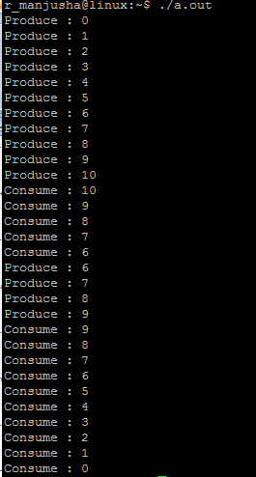

Consumer-Producer Problem –
Using pthreads(Binary Semaphores)

#include<stdio.h>
#include<pthread.h>
#include<semaphore.h>
#define SHARED 1
void *Producer(); // Make Declaration of Producer
void *Consumer(); // Make Declaration of Consumer
sem_t empty, full, sm; //Declare semaphores to be used
int data; // data variable

int main()
{
pthread_t ptid, ctid; // Line 1
printf("\nMain Started");
sem_init(&empty, SHARED, 1); // Line 2
sem_init(&full, SHARED, 0); // Line 3
sem_init(&sm, SHARED, 1);// Line 4
pthread_create(&ptid,NULL,Producer,NULL); // Line 5
pthread_create(&ctid,NULL,Consumer,NULL); // Line 6
pthread_join(ptid,NULL); // Line 7
pthread_join(ctid,NULL); // Line 8
printf("\nMain done\n");
}
void *Producer()
{
//ITEM PRODUCED...
int produced;
printf("\nProducer created");
printf("\nProducer id is %ld\n",pthread_self()); //print thread id
for(produced=0;produced<10;produced++)
{
sem_wait(&empty);
// LOCK-starts
sem_wait(&sm);
//CRITICAL SECTION STARTS
data=produced;

printf("\nProducer: %d",data);

//CRITICAL SECTION ENDS
sem_post(&sm);
//LOCK-ends
sem_post(&full);
}
}
void *Consumer()
{
int consumed;
printf("\nConsumer created\n");
printf("\nConsumer id is %ld\n",pthread_self());
for(consumed=0;consumed<10;consumed++)
{
sem_wait(&full);
//LOCK-starts
sem_wait(&sm);
//CRITICAL SECTION STARTS

printf("\nConsumed: %d",data);

//CRITICAL SECTION ENDS
sem_post(&sm);
//LOCK-ends
sem_post(&empty);
}

}

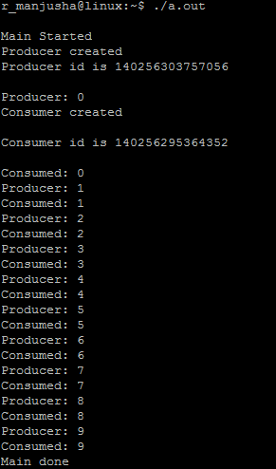

Consumer-Producer Problem –
Using pthreads(Counting Semaphores)

#include <pthread.h>
#include <semaphore.h>
#include <stdlib.h>
#include <stdio.h>

#define MaxItems 5 // Maximum items a producer can produce or a consumer can consume
#define BufferSize 5 // Size of the buffer

sem_t empty;
sem_t full;
int in = 0;
int out = 0;
int buffer[BufferSize];
pthread_mutex_t mutex;

void *producer(void *pno)
{
int item;
for(int i = 0; i < MaxItems; i++) {
item = rand(); // Produce an random item
sem_wait(&empty);
pthread_mutex_lock(&mutex);
buffer[in] = item;
printf("Producer %d: Insert Item %d at %d\n", *((int *)pno),buffer[in],in);
in = (in+1)%BufferSize;
pthread_mutex_unlock(&mutex);
sem_post(&full);
}
}
void *consumer(void *cno)
{
for(int i = 0; i < MaxItems; i++) {
sem_wait(&full);
pthread_mutex_lock(&mutex);
int item = buffer[out];
printf("Consumer %d: Remove Item %d from %d\n",*((int *)cno),item, out);
out = (out+1)%BufferSize;
pthread_mutex_unlock(&mutex);
sem_post(&empty);
}
}

int main()
{
pthread_t pro[5],con[5];
pthread_mutex_init(&mutex, NULL);
sem_init(&empty,0,BufferSize);
sem_init(&full,0,0);

int a[5] = {1,2,}; //Just used for numbering the producer and consumer

for(int i = 0; i <2 ; i++) {
pthread_create(&pro[i], NULL, (void *)producer, (void *)&a[i]);
}
for(int i = 0; i < 2; i++) {
pthread_create(&con[i], NULL, (void *)consumer, (void *)&a[i]);
}

for(int i = 0; i < 2; i++) {
pthread_join(pro[i], NULL);
}
for(int i = 0; i < 2; i++) {
pthread_join(con[i], NULL);
}

pthread_mutex_destroy(&mutex);
sem_destroy(&empty);
sem_destroy(&full);
return 0;
}

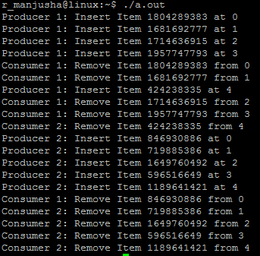
Readers-Writers Problem –
Using pthreads(Counting Semaphores)-Priority given for Readers

//readers-writers
#include <pthread.h>
#include <semaphore.h>
#include <stdio.h>

sem_t wrt;
pthread_mutex_t mutex;
int cnt = 1;
int numreader = 0;

void *writer(void *wno)
{
sem_wait(&wrt);
cnt = cnt*2;
printf("Writer %d modified cnt to %d\n",(*((int *)wno)),cnt);
sem_post(&wrt);

}
void *reader(void *rno)
{
// Reader acquire the lock before modifying numreader
pthread_mutex_lock(&mutex);
numreader++;
if(numreader == 1) {
sem_wait(&wrt); // If this id the first reader, then it will block the writer
}
pthread_mutex_unlock(&mutex);
// Reading Section
printf("Reader %d: read cnt as %d\n",*((int *)rno),cnt);

// Reader acquire the lock before modifying numreader
pthread_mutex_lock(&mutex);
numreader--;
if(numreader == 0) {
sem_post(&wrt); // If this is the last reader, it will wake up the writer.
}
pthread_mutex_unlock(&mutex);
}
int main()
{

pthread_t read[10],write[5];
pthread_mutex_init(&mutex, NULL);
sem_init(&wrt,0,1);

int a[10] = {1,2,3,4,5,6,7,8,9,10}; //Just used for numbering the producer and consumer

for(int i = 0; i < 10; i++) {
pthread_create(&read[i], NULL, (void *)reader, (void *)&a[i]);
}
for(int i = 0; i < 5; i++) {
pthread_create(&write[i], NULL, (void *)writer, (void *)&a[i]);
}

for(int i = 0; i < 10; i++) {
pthread_join(read[i], NULL);
}
for(int i = 0; i < 5; i++) {
pthread_join(write[i], NULL);
}

pthread_mutex_destroy(&mutex);
sem_destroy(&wrt);

return 0;

}

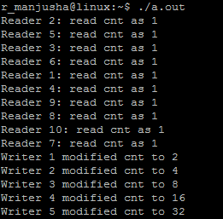

Practice:
Provide the solution for readers-writers problem using semaphores ,where writers are given priority.

